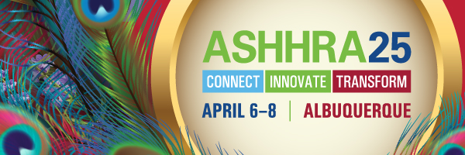

**Exhibitor Marketing Toolkit | *Spread the Word!***

**This Exhibitor Marketing Toolkit is intended to help you promote your participation at ASHHRA25: Connect, Innovate, Transform**

By using one or more of the elements of this toolkit, you will be helping promote registration for the ASHHRA25 annual conference and exposition while highlighting your business. While ASHHRA continues its traditional outreach, marketing is about reaching the right audiences with the right messages in the right format. That’s why we are asking for your help: an Exhibitor’s circle of contacts can prove to be indispensable.

As a solution provider, this toolkit allows you to announce your upcoming participation to your professional network in a simple and “branded” way. All solution providers are being offered the same materials.

Use of downloadable graphics.

Share on social media platforms.

Questions? Email: [ASHHRA@ashhra.org](mailto:ASHHRA@ashhra.org)



# **Complimentary Guest Registrations**

# As a benefit of your exhibition at the ASHHRA annual conference, we would like to give you the opportunity to invite a guest with a complimentary Full Conference registration. You may provide this offer to your organization’s Practitioner* partners, VIPs, new or potential clients, other members of the healthcare HR community with whom you have a relationship, or someone who would find value in attending the conference. More details are in the following link: [ASHHRA25 Sponsor/Exhibitor Guests](https://app.smartsheet.com/b/form/f3d21209ef2f48dd9b4b8cee03c50187)

**Share On Social Media**

Social media is an easy and effective way to let your professional connections know you will be an exhibitor at ASHHRA25! Here are sample messages you can personalize and share. Be sure to include one of the graphics (links to download below) with the post, event URL, and use the hashtag #ASHHRA25. Additional optional hashtags are as follows: #healthcare #healthcareHR #humanresources #ABQ #TrueABQ #Albuquerque

My company [INSERT COMPANY NAME] is excited to be exhibiting at #ASHHRA25 in Albuquerque! Stop by and say hello at our booth [insert booth #]! Register today: [ASHHRA25-Attend - ASHHRA](https://ashhra.org/ashhra25-attend/) #ABQ #TrueABQ #Albuquerque

Want to learn more about [insert company]? We’ll be providing demos at ASHHRA25 in Albuquerque and we have a limited number of FREE Full Conference registrations to give out. Message us here ASAP if you’re interested! Check out the full #ASHHRA25 program here: [ASHHRA25 Sessions - ASHHRA](https://ashhra.org/ashhra25-sessions/)*#ASHHRA25* #ABQ #TrueABQ #Albuquerque

We’re exhibiting at ASHHRA25 in Albuquerque, booth [insert booth #] and we’d like to invite you! DM us about a COMPLIMENTARY Full Conference registration. Limited availability. [Insert Registration Link] *#ASHHRA25* #ABQ #TrueABQ #Albuquerque

# **Graphics**

## Right-click on the images below to save it to your computer. These graphics can be used on social media, posted on your website, and added to your email signature. Be sure to include the event URL (or link the graphics) and hashtag in your posts: [ASHHRA25-Attend - ASHHRA](https://ashhra.org/ashhra25-attend/) *#ASHHRA25* #ABQ #TrueABQ #Albuquerque

